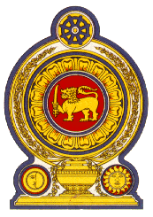
Statement by the Democratic Socialist Republic of Sri Lanka
27th Session of the Universal Periodic Review
Review of Ecuador - 01 May 2017

Mr. President,

Sri Lanka welcomes the delegation of Ecuador to the UPR Working Group and thanks them for its comprehensive national report and the presentation this afternoon.

We congratulate Ecuador for the achievements and the progress made in its follow up to its second UPR.

Taking note of the Government’s efforts since the previous UPR cycle to implement the National Plan for Good Living (PNBV) 2013-2017, Sri Lanka wishes to recommend that the Government of Ecuador makes specific efforts to combat discrimination, and to improve the levels of education and health of its people.

Following the devastating earthquake in the country in April 2016, we recognize the resilience and the efforts made by the Government for ‘building back better’ and encourage the Government to invest in disaster risk reduction measures.

Finally, we wish Ecuador success in its UPR engagement.

Thank you.

